# Project Adviser

**Vision**

Reduce the duration and improve the consistency of selling professional services engagements by utilizing algorithms and historical data.

**Current challenges**

There are many challenges impacting the PS selling process that could be solved by building a new application:

1. **Statements of Work contain tasks that are inconsistent across different regions.** We heard repeated complaints from consultants during SKO 2017 that our SoW tasks are difficult to understand. In addition, several customers have misinterpreted our tasks to be more than we intended and we’ve sent consultants to remedy the situation free of charge.
2. **Ramp-up time for a new Client Solutions Director is lengthy.** Because there is no central repository, it takes time for a new CSD to develop knowledge needed to create and negotiate a statement of work. Those who sell PS engagements get asked “why does it take so long” and the answer is difficult to come by for someone just starting in this role.
3. **Selling PS engagements relies on the expertise of one person.** Again, due to a lack of a central repository every CSD is on their own to estimate the projects in front of them. Some CSDs utilize Architects/Consultants to help estimate, but that does not benefit from global expertise contained of the organization nor does it scale.
4. **We lack a way of finding similar projects.** Customers often want to know that they are not alone in the work they request from us, but we do not have the tools to search through the tasks of prior projects. Instead, CSDs rely on e-mails sent to a global list, but that is not a method that can scale.

**Benefits**

These are the benefits that we could achieve by creating this application. Some of these map directly to the challenges above, but others are beneficial side effects of investing in this effort.

1. Eliminate ambiguity and inconsistencies that exist in SoWs across different projects and different regions
2. Improve accuracy of project durations by using lessons learned from prior projects
3. Speed up SoW generation process by using a predefined list of offerings and a Web UI for customization
4. Reduce time to on-board new Client Solutions Directors by creating central repository of offerings, tasks, and task durations
5. Democratize historical SoW content and leverage the expertise of the entire PS organization to create future SoW
6. Improve ability to sell services by identifying customers with similar projects
7. Improve chance of successful delivery by identifying similar projects and linking to re-usable components
8. Allow engagement managers to deliver immediate value by generating a project plan or JIRAs based on prior task durations
9. Measure maturation of the PS organization by tracking improvements in the time needed to accomplish the same task over time
10. Eat our own dogfood and allow new-hires a chance to see our products in action in a production environment

**Process flow (future state)**

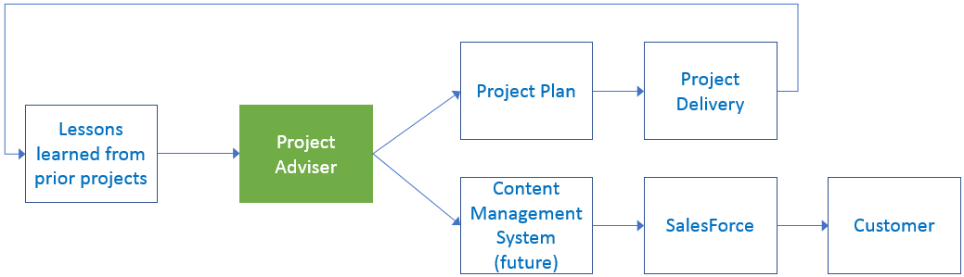

**Longer term benefits:**

We tell our customers to treat data as an asset and by doing so ourselves we create many future opportunities. Once this tool captures what tasks were part of each of our many global projects in a machine readable format then we can analyze this data and create publicly visible PS packages with the most often performed tasks. In addition, with the same data we could measure the maturation of the PS organization by tracking how long the same task took to complete today compared with three months ago. Finally, by utilizing our own technology stack on this project we create an internal Center of Excellence that new hires and existing hires can use to improve their skills and showcase to customers.